myHR.
Analysis Module

Supervisor:
Dr. Husam Al-Maghoosi

March 13th, 2026

Requirements, project, functionality

Introduction

Goal
- Provide a digital platform to manage employee records, organizational hierarchy, promotions, and allowances.
- Replace manual HR spreadsheets with a secure, auditable, structured system for admins.
- Ensure scalability (support 5,000+ employees) and thesis extensibility (rule configuration, reporting, history).

Application domain
- Government-like organizations, large companies, or HR consultancy services.
- Use cases: employee tracking, promotion management, commendation/sanction monitoring, reporting, onboarding via CSV import.

References
- Research papers on E-HRMS, HR automation, and system design).
- Agile methodology references.
- Python, Flet, PySide6, SQLite, SQLAlchemy official docs.

Document content
- Chapter 2 describes requirements, functionalities, and use-cases.
- Includes UI mockups, hierarchy diagrams, CSV import process, and admin/employee workflows.
- Serves as design and planning reference for coding and testing.

Overview

General overview
- Architecture: Desktop application, local database (SQLite), modular design: GUI layer → business logic → database.
  - Subsystems:
  - Organization & department management
  - Employee management (CRUD + promotions + commendations)
  - Rule engine for promotions
  - Import/export module
  - Audit/history module
- Interfaces: GUI for admin and employee; CSV/Excel import interface.
- Data storage: Local SQL-based database.

Functions
- Employee Management: Add, edit, delete, and view employee records with personal and organizational details.
- Organizational Hierarchy Management: Manage Organization → Departments → Units → Employees, including leadership roles (e.g., CEO, HOD, Unit In-Charge).
- Promotion Management: Admin can select employees for promotion; system applies time-based thresholds and commendation-based early promotion logic. Next promotion starts from scratch (previous commendations do not carry over).
- Commendation and Sanction Management: Apply recognition points or disciplinary actions with configurable durations.
- Bulk Employee Import: Admin can upload employee data via CSV/Excel. System validates and cleans input; admin guide and short training provided to prevent data errors.
- Manual Employee Addition: Admin can add employees individually, filling mandatory details to ensure proper integration into hierarchy and payroll logic.
- Role-Based Access: Multi-user approach with different access levels: Admin, HR Officer, Department Head, and Employee. Employees can view limited fields and edit only optional items (profile picture, LinkedIn, active/inactive status).
- Audit / Change Log: All admin actions are logged, including who made the change, what was changed, and when, preventing misuse or nepotism in promotions.
- Reporting: Generate employee reports, promotion history, commendations/sanctions, and CSV export for organizational overview.
- Future Enhancements (Planned): Restrict admin actions to only their department/unit based on role (e.g., CEO full access, Department Head restricted to own department).

Users
- Admin: full access; manages employees, promotions, hierarchy, CSV import.
- Employee: limited view; can see organizational position, optional fields editable.
- System assumes basic IT literacy for admin (e.g., cleaning CSV before import).

Hierarchy
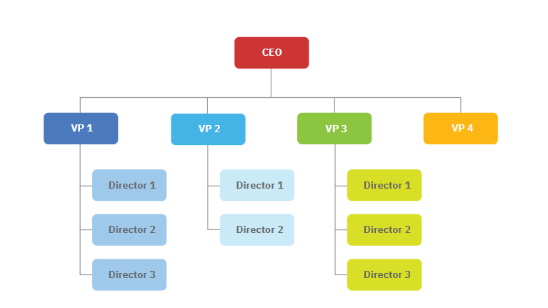

Requirements

Functional requirements
ID | Description | Check | Priority | Source | Use-case | Comment
FR1 | Add/Edit/Delete/View Employee | Manual / UI Test | Must | Prof input | Manage Employee | Includes personal + org details
FR2 | Assign employee to Department/Unit | Manual | Must | Prof input | Assign Roles | Supports hierarchy
FR3 | Promotion management | Logic Test | Must | Prof input | Promote Employee | Includes commendation logic + reset threshold
FR4 | Commendation / Sanction management | Logic Test | Must | Prof input | Apply HR Action | Duration configurable
FR5 | Import CSV / Excel | File test | Must | Prof input | Bulk Add | Admin guide required
FR6 | Manual Add Employee | UI test | Must | Prof input | Add Employee | Form validation required
FR7 | Employee profile view | UI test | Must | Prof input | View Profile | Optional editable fields
FR8 | Audit / reporting | UI / CSV export | Should | Prof input | Generate Report | Optional export to CSV

Resource requirements
ID | Description | Check | Priority | Source | Comment
RR1 | Local Desktop / Laptop | Manual | Must | Standard | Windows/Linux
RR2 | Python 3.x | Run test | Must | Tech stack | For backend logic
RR3 | SQLite DB | Data integrity | Must | Tech stack | Scales for 5,000+ employees
RR4 | Flet / PySide6 | UI test | Must | Tech stack | Chosen based on professor approval
RR5 | GitHub repository | Version check | Should | Prof input | Shared access for updates

Non- functional requirements, Restrictions

ID | Description | Check | Priority | Source | Comment
NFR1 | Security / Data Privacy | Manual | Must | Prof input | Employee sensitive info not editable by self
NFR2 | UI responsiveness | Manual | Must | UX | Friendly, modern, intuitive
NFR3 | Performance | Load test | Must | Tech stack | 5,000+ employee records supported
NFR4 | Learnability | User test | Should | Prof input | Admin guide for CSV import & forms
NFR5 | Auditability / Log Tracking | Manual / System logs | Must | Prof input | System keeps track of who changed what and when. Prevents misuse or nepotism in promotions.
NFR6 | Admin Role Restrictions | Logic test | Should | Prof input | In future, admins may be restricted to managing only their department/unit based on position (e.g., CEO, HR, Department Head).

Essential use-cases
- Actors: Admin, Employee
- Use cases: Manage Employees, Manage Hierarchy, Manage Promotions, Apply Commendation/Sanction, CSV Import, Manual Add Employee, View Profile, Generate Reports
- Diagram: Can be drawn in PlantUML / Graphor, add boxes for actors and use-cases.

Use-case diagram
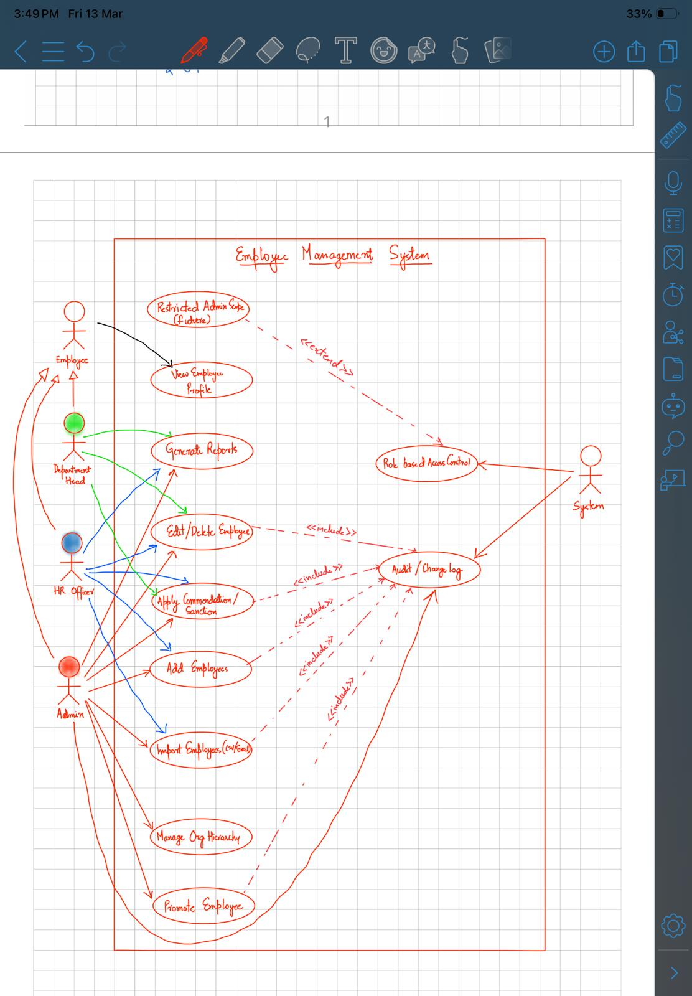

Use-case descriptions
UC01 – Add Employee
Use-case name | Add Employee
Short description | Admin or HR Officer manually adds a new employee by filling in required personal and organizational details. The system validates the input and saves the record.
Actors | Admin, HR Officer
Dialog / Scenario | 1. Actor clicks "Add Employee"  2. System displays the employee entry form  3. Actor fills in mandatory personal details (name, DOB, contact, etc.)  4. Actor fills in organizational details (department, unit, title, role)  5. System validates all mandatory fields  6. If validation fails → system highlights errors, actor corrects and resubmits  7. System saves the employee record to the database  8. System creates an audit log entry (who added, what, when)
UC02 – Import Employees (CSV/Excel)
Use-case name | Import Employees (CSV/Excel)
Short description | Admin or HR Officer uploads a CSV or Excel file containing multiple employee records. The system validates and cleans the data, previews results, and imports valid records in bulk.
Actors | Admin, HR Officer
Dialog / Scenario | 1. Actor clicks "Import Employees"  2. System displays file upload interface with a downloadable admin guide/template  3. Actor selects and uploads a CSV or Excel file  4. System validates file format and checks all mandatory fields per row  5. System displays a preview table highlighting:  - Valid rows ready for import  - Rows with errors and the reason for each  6. Actor reviews the preview  7. If errors exist → actor can correct the file and re-upload, or skip invalid rows  8. Actor confirms the import  9. System saves all valid employee records to the database  10. System creates an audit log entry for the bulk import action
UC03 – Edit / Delete Employee
Use-case name | Edit / Delete Employee
Short description | Admin or HR Officer can update an existing employee's details or remove an employee record from the system. All changes are logged for accountability.
Actors | Admin, HR Officer, Department Head
Dialog / Scenario | 1. Actor searches for or navigates to the target employee record  2. System displays the employee's full profile  3. Edit path:  a. Actor clicks "Edit"  b. System opens the editable form with current values pre-filled  c. Actor modifies the desired fields  d. System validates updated inputs  e. If validation fails → system highlights errors, actor corrects and resubmits  f. System saves the updated record  4. Delete path:  a. Actor clicks "Delete"  b. System displays a confirmation prompt  c. Actor confirms deletion  d. System removes or archives the employee record  5. System creates an audit log entry capturing who made the change, what was changed, and when

UC04 – Promote Employee
Use-case name | Promote Employee
Short description | Admin selects an employee for promotion. The system evaluates eligibility based on time-in-role thresholds and commendation points. Upon confirmation, the promotion is applied and the next promotion cycle resets from scratch.
Actors | Admin
Dialog / Scenario | 1. Admin navigates to the target employee's profile  2. Admin clicks "Promote Employee"  3. System evaluates promotion eligibility based on:  - Time-based threshold (standard promotion timeline)  - Commendation-based early promotion (if enough points accumulated)  4. System displays available next titles the employee is eligible for  5. If employee is not yet eligible → system displays reason and estimated eligibility date  6. Admin selects the target promotion title  7. System displays a confirmation summary showing:  - Current title → New title  - Promotion basis (time-based or commendation-based)  8. Admin confirms the promotion  9. System applies the new title to the employee record  10. System resets the promotion cycle — previous commendations do not carry over to the next cycle  11. System creates an audit log entry capturing who approved, what changed, and when
UC05 – Apply Commendation / Sanction
Use-case name | Apply Commendation / Sanction
Short description | Admin, HR Officer, or Department Head applies a commendation (recognition points) or a sanction (disciplinary action) to an employee. The action is configurable in type, points, and duration, and is fully logged.
Actors | Admin, HR Officer, Department Head
Dialog / Scenario | 1. Actor navigates to the target employee's profile  2. Actor clicks "Apply Commendation / Sanction"  3. System displays a form with the following options:  - Commendation: recognition type, points awarded, remarks  - Sanction: disciplinary type, severity, duration, remarks  4. Actor selects the action type (Commendation or Sanction)  5. Actor fills in the required details (type, points/duration, remarks)  6. System validates the input  7. If validation fails → system highlights errors, actor corrects and resubmits  8. System saves the commendation or sanction to the employee record  9. System updates the employee's commendation points balance (if commendation) which may affect promotion eligibility  10. System creates an audit log entry capturing who applied the action, what type, and when

UC06 – View Employee Profile
Use-case name | View Employee Profile
Short description | An employee logs in and views their own profile. They can only see permitted fields and are allowed to edit a limited set of optional personal details. Protected fields require a correction request to be sent to the admin.
Actors | Employee
Dialog / Scenario | 1. Employee logs into the system  2. System authenticates the employee and loads their profile based on role-based access rules  3. System displays permitted viewable fields only, including:  - Personal details (name, contact, position, department)  - Commendation / sanction history  - Promotion history  4. Employee reviews their profile information  5. Edit optional fields path:  a. Employee clicks "Edit Profile"  b. System allows editing of optional fields only:  - Profile picture  - LinkedIn profile URL  - Active / Inactive status  c. Employee saves changes  d. System updates the record and logs the change  6. Request correction path:  a. Employee identifies an error in a protected field  b. Employee clicks "Request Correction"  c. Employee describes the correction needed  d. System forwards the request to the Admin for review

UC07 – Manage Organizational Hierarchy
Use-case name | Manage Organizational Hierarchy
Short description | Admin manages the full organizational structure including Organizations, Departments, Units, and the employees assigned within them. Leadership roles such as CEO, Head of Department, and Unit In-Charge are also assigned and managed here.
Actors | Admin
Dialog / Scenario | 1. Admin navigates to the "Organization Hierarchy" section  2. System displays the current hierarchy in a structured tree view:  - Organization  - Departments  - Units  - Employees  3. Add path:  a. Admin clicks "Add" at the desired level (Department, Unit, etc.)  b. System displays a form for the selected level  c. Admin fills in required details and assigns a leadership role if applicable  d. System validates and saves the new node to the hierarchy  4. Edit path:  a. Admin selects an existing node and clicks "Edit"  b. System displays the current details in an editable form  c. Admin updates the details or reassigns leadership roles  d. System validates and saves the changes  5. Delete path:  a. Admin selects a node and clicks "Delete"  b. System checks if the node has dependent employees or sub-units  c. If dependencies exist → system warns Admin and blocks deletion until resolved  d. If no dependencies → system asks for confirmation and removes the node  6. System creates an audit log entry for all hierarchy changes

UC08 – Role-Based Access Control
Use-case name | Role-Based Access Control
Short description | The system enforces different access levels for each user role. Each role is granted specific permissions to view, edit, or manage data within the system, ensuring that users can only perform actions appropriate to their role.
Actors | Admin, HR Officer, Department Head, Employee, System
Dialog / Scenario | 1. User attempts to log into the system  2. System authenticates the user and identifies their assigned role:  - Admin: Full access to all modules, employees, and system settings  - HR Officer: Can add, edit, import employees and apply commendations/sanctions; cannot access system settings  - Department Head: Can view and manage employees within their own department only; limited edit rights  - Employee: Can view own profile only; can edit optional fields (profile picture, LinkedIn, active/inactive status)  3. System loads the interface and menu options based on the user's role  4. User attempts to perform an action  5. Authorized path:  a. System confirms the action is within the user's permitted scope  b. System allows the action to proceed  6. Unauthorized path:  a. System detects the action is outside the user's permitted scope  b. System blocks the action and displays an access denied message  c. System logs the unauthorized attempt in the audit log  7. System continuously enforces role permissions throughout the entire session

UC09 – Audit / Change Log
Use-case name | Audit / Change Log
Short description | The system automatically records all admin and HR actions performed within the system. Authorized users can review the logs to monitor changes, detect misuse, and ensure accountability especially for sensitive actions like promotions.
Actors | Admin, HR Officer, System
Dialog / Scenario | 1. System automatically triggers a log entry whenever any of the following actions occur:  - Employee added or imported  - Employee record edited or deleted  - Promotion applied  - Commendation or sanction applied  - Organizational hierarchy changed  - Unauthorized access attempt detected  2. System records the following details for each log entry:  - Who performed the action (user & role)  - What was changed (before & after values)  - When it occurred (timestamp)  3. Admin navigates to the "Audit Log" section  4. System displays a searchable and filterable log table  5. Admin filters logs by date range, user, action type, or affected employee  6. System returns matching log entries  7. Admin reviews the log details  8. Suspicious activity path:  a. System detects unusual patterns (e.g. multiple promotions in short succession)  b. System flags or alerts the authorized user for review

UC10 – Generate Reports (optional)
Use-case name | Generate Reports
Short description | Admin, HR Officer, or Department Head can generate various reports on employees, promotions, commendations, and sanctions. Reports can be viewed within the system or exported as CSV for external use.
Actors | Admin, HR Officer, Department Head
Dialog / Scenario | 1. Actor navigates to the "Reports" section  2. System displays available report types:  - Employee Report: full list of employees with organizational details  - Promotion History Report: promotion records per employee or department  - Commendation / Sanction Report: recognition and disciplinary history  - Organizational Overview Report: hierarchy and headcount summary  3. Actor selects the desired report type  4. System displays filter options such as:  - Date range  - Department or unit  - Employee name or ID  5. Actor applies preferred filters and clicks "Generate"  6. System processes the query and displays the report in a structured table view  7. Actor reviews the report on screen  8. Export path:  a. Actor clicks "Export as CSV"  b. System generates and downloads the CSV file to the actor's device  9. System logs the report generation action in the audit log

Glossary
A
- Admin: Authorized user managing HR system.
- Audit Log: Record of all system changes, including who made the change, what was changed, and timestamp, to prevent misuse.
C
- Commendation: Recognition points that can accelerate promotions.
- CSV Import: Bulk employee data addition from spreadsheet.
D
- Department: Main division under organization or parent department.
E
- Employee: User with limited access, views own profile.
M
- Manual Add: Single employee addition via form.
N
- Nepotism Prevention: System features (audit log + role restrictions) to prevent promotion misuse or favoritism.
P
- Promotion Policy: Rules governing title progression.
S
- Sanction: Penalty assigned with duration.
- Scoped Admin / Department Admin: Admin restricted to managing only specific department or unit. Future extension.
U
- Unit: Subdivision of a department in the organization.

